How to work Brant-Entry Shiny App

Steps To Do Once at Start of Season

Do these steps on each device you will want to enter data on!

1. Download R onto laptop/tablet if it is not on the device already – requires internet connection
   1. Run these lines of code, what it does is check if packages are installed, and if they aren’t it installs them

ipak <- function(pkg){

new.pkg <- pkg[!(pkg %in% installed.packages()[, "Package"])]

if (length(new.pkg))

install.packages(new.pkg, dependencies = TRUE)

sapply(pkg, library, character.only = TRUE)

}

packages <- c("shiny", "shinyjs", "shinythemes", "dplyr", "DT")

ipak(packages)

1. Install a browser (not AOL please) if you don’t have one already – requires internet connection
2. Go to <https://github.com/sagelinae/Brant-Data-Entry> and click the green button that says “Clone or Download” – requires internet connection
   1. Then click “Download ZIP”
   2. Go into your downloads and right click the folder you downloaded called “Brant-Data-Entry-master” and select Extract All
   3. This brings up a popup for the destination, click browse and extract this folder to wherever you want to keep the data (desktop, under documents, ect)

***Not sure if this is where we’ll keep it forever but this is where it is for now ☺

Files that you should see:

* Folder called Data with three subfiles BAND/EGG/NEST2019.csv
* app.R
* combine_files.R
* Three template files called Band/Egg/NestTemplate.csv
* One Windows Batch File script called BrantEntry
* One VBScript file called Brant Data Entry
* A markdown file called README.md (mostly for initial download on github)
* This word document ☺

1. If you want to save some time typing later right click the folder wherever you saved it to and rename it to something easier, I renamed it “Brant-Data”
2. In your folder “Brant-Data”, right click on any blank space and click “New” and then click “Folder”
   1. Name your new folder “Backups”
   2. Inside this folder do the same process to create three subfolders called “Band”, “Egg”, and “Nest” as seen in the picture below

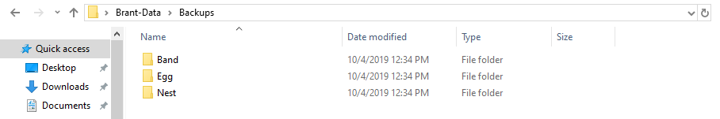

1. Open the app.R file and look for comments with a *** symbol. (You can ctrl-F ***) This requires some sort of action to be done once at the **start of the season** before entering data. These file pathways may be different for each laptop you’re entering data on! These actions are:
   1. Set the working directory. This should be the filepath to wherever you moved the Brant-Data folder. For ex: " C:\\Users\\sellis\\Desktop\\Brant-Data "
   2. Enter a filepath to the directory where you are going to save your backups to for each of the folders we created above. Ex:

"C:\\Users\\sellis\\Desktop\\Brant-Data\\Backups\\Nest\\"

"C:\\Users\\sellis\\Desktop\\Brant-Data\\Backups\\Band\\"

"C:\\Users\\sellis\\Desktop\\Brant-Data\\Backups\\Egg\\"

* 1. Add the filepath to the location where the nest/band/egg file is you wish to update – make sure it’s a csv! Ex:

"C:\\Users\\sellis\\Desktop\\Brant-Data\\Data\\NEST2020.csv"

* + 1. If it’s the first entry then make a blank .csv file with the same column names as previous ones. The Github downloads some blank ones already that you can use, just rename for whatever year it is!
  1. In the server part of the shiny app, where it says “YEAR” = “2020” change 2020 to whatever the current year is.
     1. This will be need to be done **twice**, once under formData and again under egginputs
     2. Make sure the year you enter is in quotes! “YEAR” = 2020 will throw an error where as “YEAR” = “2020” works!

1. Save your changes and exit app.R; a popup will happen asking you if you want to save workspace image, click “Don’t Save”
2. Right click on the file called BrantEntry.bat and click EDIT
   1. If a notice that says “Windows protected your PC” pops up; click “More Info”, then click “Run anyway”.
   2. Change the pathway on the right of the -e to be the pathway where the app is located. This should be the same as the working directory we set in app.R, the picture below highlights the part you should change



* 1. The pathway left of -e will probably be the same on any windows computer if you have the same version of R, but you should double check that program Rscript.exe is located in that pathway just to be sure!!
     1. The folder R-3.6.0 is the folder most likely to be different, make sure to double check it.
  2. Exit this script and save your changes.

1. Right click on the filed named Brant Data Entry.vbs and click EDIT – ignore warnings lol
   1. Change the file pathway again. Should be the working directory and the name of BrantEntry.bat. See example picture below. Then exit and save the script.

NOTE: Yes, there should be three quotes on both sides. If for some reason your pathway has a folder with a space name (Ex: “C:\Users\Jsedinger Field2\...) using three quotes allows vbs to read it still, if you only have one quote it will say pathway not found even if the pathway is correct.

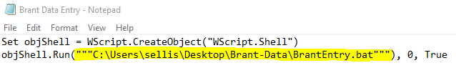

1. Right click the file named Brant Data Entry (the VBScript) and click “Create Shortcut”
   1. Move this shortcut onto the desktop
   2. If you want to change the icon, right click your desktop shortcut, click “Properties”, click “Change Icon” and pick an icon to change it to. I like the tree. Then click “Ok”

You’re Ready to Start Entering Data!

1. When you’re ready to enter data just click the file Brant Data Entry - Shortcut on your desktop and you’re good to start entering!
2. Backup your backups onto a jump drive! And one other place? Should back it up somewhere else too, not sure the most effective way to do that
3. Your data will not automatically synch between laptops, so occasionally you’ll need to move files from one laptop to another and run script combine_files.R to combine the data. Details in next section below.

TROUBLESHOOTING:

* If the shortcut looks grey, and clicking submit/save does not do anything, then you most likely entered a pathway wrong. Here are the steps to check:
  1. Open app.R
  2. Click Run App in the top right corner
  3. You should see an error message, look at the pathway and see which one you need to fix.
  4. If Run App in app.R works properly, your next step is to double click and try and run BrantEntry.bat; if that does not run then double check the pathway in the .bat file
  + Some common errors in pathways you might have done:
    - Not using double slashes in app.R pathways; r can’t read C:\Users\sellis; you need to use double slashes and use C:\\Users\\sellis
    - Forgetting a folder. Our data is in \\Brant-Data\\Data\\NEST2020.csv; if you only write \\Brant-Data\\NEST2020.csv then r can’t find the correct pathway.
    - The pathways are different for the .bat and .vbs files. In the .bat file we use / instead of \

Some notes on the app itself:

* If you don’t click SAVE then your entry will not be appended onto the file! Submit just lets you see what you entered.
* If you make a mistake and don’t realize until after you hit submit and/or save you’ll need to go into the .csv file to fix it. I don’t have a way to delete an entry yet before you hit save.
* Honestly I don’t know why there’s a submit *and* save button, submit is just so you can see the table of your current entries, but save is what you need to do before it saves to the file. Maybe in the future this can be changed just to one save button.
* The see previous observations of nest box will bring up a new tab where it shows you all the previous entries for a specific nest – could be handy for double checking things like band reads at that nest! Idk you decide
* Band file data will be populated automatically from Nest data. If you have tower information you’ll probably need to go directly into the .csv to add that. THOMAS?
* This app automatically creates backups and it will overwrite the original file; but the backup will save the old file!
  + Backups will be named in this format: filename_month(mm)_day(dd)_hour(military time)_minute
  + Backups happen twice every time you run the app, once at the start and once at the end. So if you open the app, enter some data, and close it, you will have two new backups.

Backing Up and Combining Data from Different Devices

* The scripts will automatically backup data for you into folders on your device. These will be slightly different between computers since you’re entering different data
* Backup your backup folders onto a flash drive! And somewhere else!!

Combining Data

1. Move your three files (Nest, Band, and Egg) from one computer onto a flash drive. Transfer these to the second computer into the folder where the files you want to combine are.
   1. A notification will pop up saying “The destination already has a file named x”
   2. Click: “Compare info for both files” – also sometimes “Let me decide for each file”
   3. Click both check boxes under “Which files do you want to keep” – this will just add (2) onto the name of the file we’re transferring over
   4. Your data folder should look like this when it’s been moved over

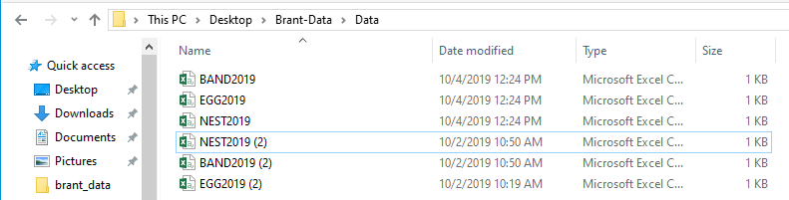

1. Open combine_files.R and look for the *** to change pathways to be correct for whatever device you are on.
   1. The backup directories should be the same as what they are in the app.R
   2. The directory for where your data is saved should also be in app.R where you upload the files you want to add to (pathway, b_pathway, e_pathway in app.R)
2. Run combine_files.R by highlighting it all (ctrl-A) and hitting run in the top right corner of the screen or by typing ctrl-enter
   1. This will overwrite the file without a number and then delete the file with a number. Ex: You have band.csv, you copy over the file from a second computer and have band (2).csv; once run through the script the combined data will overwrite band.csv and band (2).csv will be deleted.
   2. band (2).csv will have had a backup on the other device so we can delete it comfortably.
3. Put the newly combined data back onto the flash drive and transfer it back to the other computer
   1. A notification will pop up saying “The destination already has a file named x”
   2. Click: “Replace the file in the destination” (this file will have a backup from when the app itself ran so it’s fine to replace it)

Please feel free to reach out with any questions/bugs/enhancements you’d like to see.

Email: sage.linae.ellis@gmail.com